Curriculum Vitae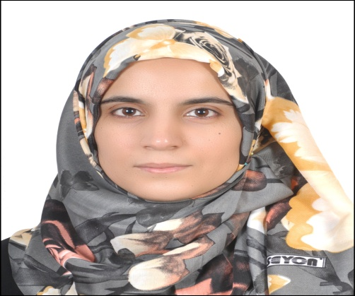

PERSONAL INFORMATION

|  |  |  |  |
| --- | --- | --- | --- |
| *Hiba Ahmed Mazed* | | | ***Name*** |
| *Iraq_karbala* | | | ***Home Address*** |
| *17/7/1992* | ***Birth Date*** | *Basra* | ***Place of Birth*** |
| *Female* | ***Gender*** | *Single* | ***Marital status*** |
| *Muslim* | ***Religion*** | *Iraqi* | ***Nationality*** |

|  |  |  |
| --- | --- | --- |
| *07733618140* | *07707043052* | ***Phone number*** |
| [*Hiba199211@gmail.com*](mailto:Hiba199211@gmail.com)  [*Hiba1992ahqq@gmail.com*](mailto:Hiba1992ahqq@gmail.com) | | ***E.MAIL*** |

***ACADEMIC QUALIFICATION***

|  |  |  |  |
| --- | --- | --- | --- |
| *Engineering* | ***College*** | *Basra* | ***University Name*** |
| *2013/2014* | ***Graduation Year*** | *Chemical Engineering* | ***Specialization*** |
| *B.S.C in Chemical Engineering* | | | ***Specialty*** |
| *3* | ***Sequence*** | *76.179%(GOOD)* | ***Graduation grade*** |

***Experience & professional qualifications***

|  |  |
| --- | --- |
| *→Trained in south oil company*  *→Graduation project: Drying Oil* | ***Experiences*** |
| →*course on OSHA Occupational safety and Health Professional 30 Hours*  *→course of (English Conversation) in cooperation with Directorate of Youth and sport of Basra* | ***Training*** |

***Computer skills***

|  |  |  |  |
| --- | --- | --- | --- |
| *professional* | | *Microsoft Word* | ***Skills*** |
| *professional* | | *Microsoft Excel* |
| *Good* | | *Microsoft power point* |
| *Good* | *Auto CAD* | |
| *Good* | *Visual Basic* | |
| *Good* | *Microsoft ACCESS* | |
| *Good* | *Corel Draw* | |

|  |  |  |  |  |
| --- | --- | --- | --- | --- |
| ***Writing*** | ***Reading*** | ***Talk*** | ***Language*** | ***Languages*** |
| *good* | *Exce.* | *good* | ***English*** |
| *Exce.* | *Exce.* | *Exce.* | ***Arabic*** |

|  |  |
| --- | --- |
| * *Developing My Computer Skills* * *Learn Foreign Languages* * *Reading* * *Travel* | ***interests*** |

***Strengths & weaknesses***

***Strengths:***

* *Easy handling package*
* *Organization at work*
* *Timely discipline*
* *Work under stress*

***Weaknesses:***

* *Felling tired*
* *I do not have a professional level in English*